**Objective Questions**

1. **The data consists of some inconsistent and missing values so ensure that the data used for further analysis is cleaned.**

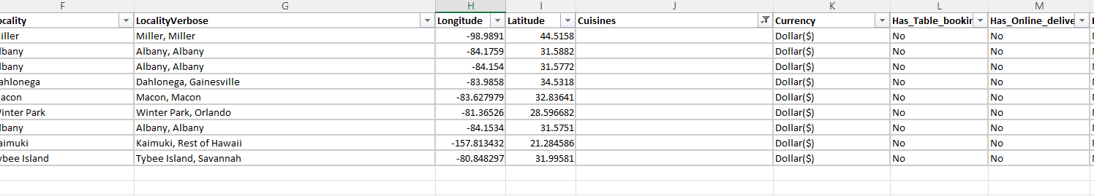

* **To clean the data and use it to further analysis we have followed the below procedure:**

*First of all, we have found the blank cell using the countblank function and filtered out the column containing the blank cell. We have filled the blank cell using the cuisine which is having the maximum count with the help of pivot taking count of cuisine in the value and cuisine in the row.*

1. **Using the LookUp functions, fill up the countries in the original data using the country code.**

* *We have used the Vlookup function to fill the countries in the original data using the country code from the sheet named “Country Description”.*



1. **Create a table to represent the number of restaurants opened in each country.**

* *We have created a pivot table for creating table to represent the number of restaurants opened in each country. We have taken country in row and Restaurant ID in value as a count which helps us to find the number of restaurants opened in each country. Below is the table and chart representing the same.*

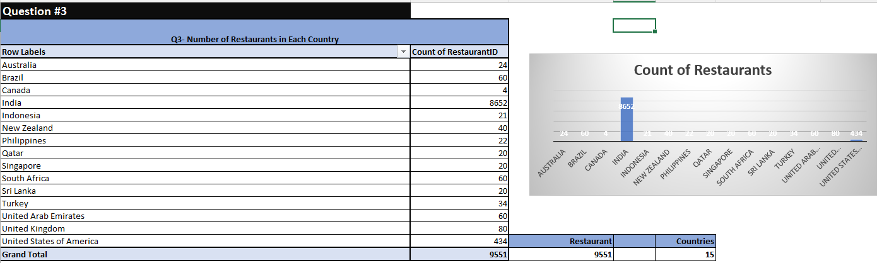

1. **Also the management wants to look at the number of restaurants opened each year, so provide them with something here.**

* *We have created a pivot table for creating tables to represent the number of restaurants opened in each country. Applying the pivot on the data we have selected year in row and restaurant ID account as in value which results in the solution of the table containing the details of the restaurant each year. Below is the table and chart representing the same.*

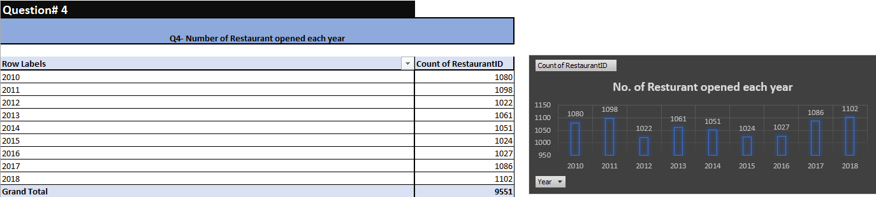

1. **What is the total number of restaurants in India which are in the price range 4?**

* *Total number of restaurants in India with the price range 4 is 388. We have entered the pivot for the data provided and put country and rating in the filter and the restaurant ID counts as value.*

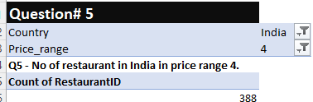

1. **What is the average number of voters for the restaurants in each country according to the data?**

* *The number of voters for the restaurants in each country according to the data are as follows. Same is represented in the below table and chart.*

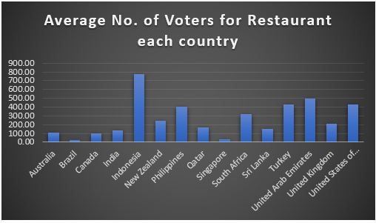

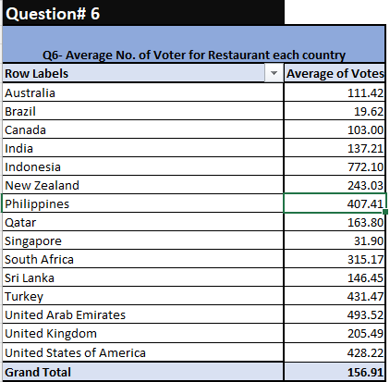

**Subjective Questions**

1. **Suggest few countries where the team can open newer restaurants with lesser competition.** Which visualization/technique will you use here in order to justify the suggestions?

* *First of all we need to decide the criteria on which we need to open the newer restaurant with lesser competition.*
* *In this case study we have focused on the multiple aspects and choose the priority accordingly. We have assigned the priorities based on the criteria.*

*In the given case study we have considered rating, votes, price and average cost for two for newer restaurants respectively.*

* *We have created the pivot table indicating country wise average rating, votes, price and average cost for two and obtained the normalized value for all the aspects taken for the decision.*

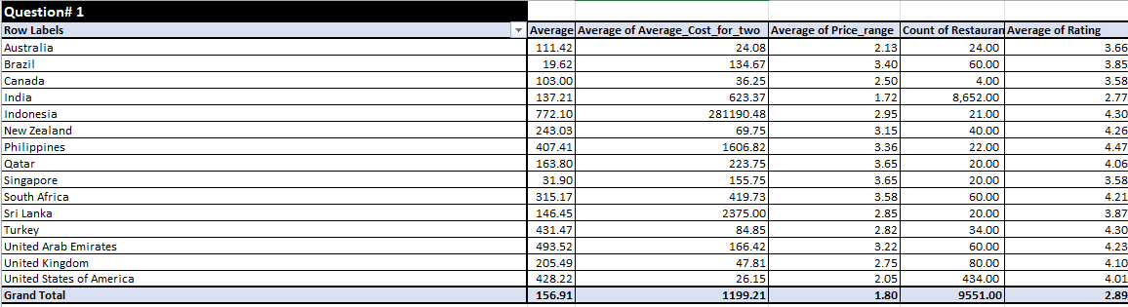

* **Formula to obtain normal= Current Value- Minimum Value**

**Maximum Value- Minimum Value**

* *Once we obtain the normalized value we will calculate the composite score for each of the countries and based on the composite score we have assigned rank to each country as shown in the below screenshot*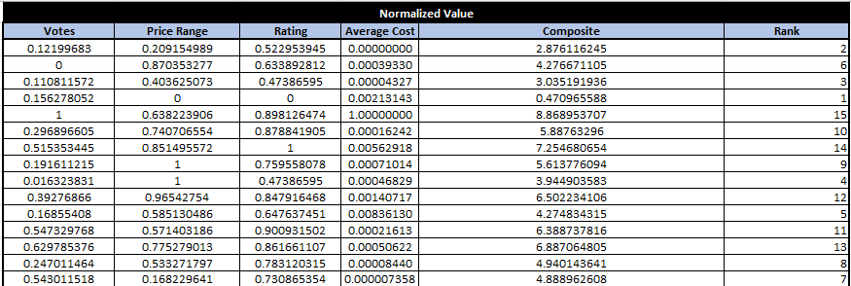

**List of the suggested countries are as below:**



1. **Come up with the names of States and cities in the suggested countries suitable for opening restaurants.**

Name the chart/spreadsheet function you will use for solving the problem?

* *For suggesting states we have followed the same procedure as we have followed to select the countries. We will find the normalized value for each of the aspects we have considered during selecting countries after that we will find the composite score. After obtaining composite score ranks are assigned using rank formula as per the composite score.*

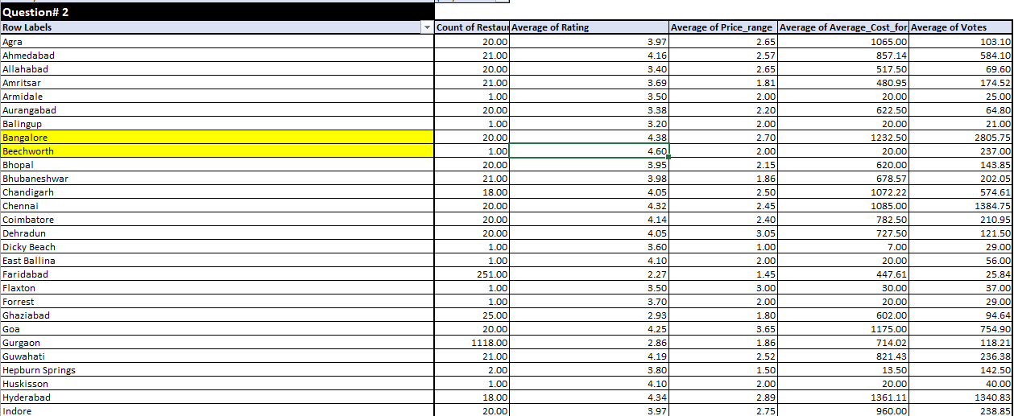

**Above is the pivot used for selecting states.**

**Below are the suggested state in the suggested countries suitable for opening restaurants**



1. **According to the countries you suggested, what is the current quality in terms of ratings for restaurants that are opened there?**

Will you use any aggregation function or a visualization here to solve the problem?

* *To find the current quality in terms of ratings for restaurants that are opened there we have to create the pivot table and need to take the country in row and rating in the value field with average. Below is the table and chart for the same.*

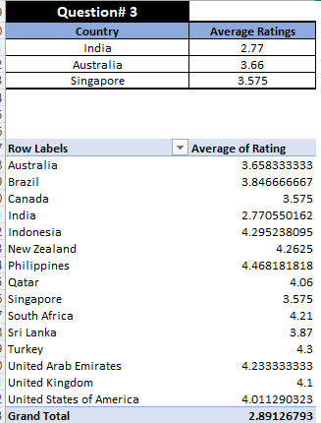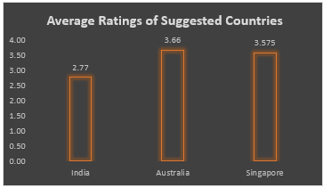

1. **Also what is the current expenditure on the food in the suggested countries, so that we can keep our financial expenditure in control?**Mention the functionality which you will use for giving the suggestions, will it be any aggregate function or a visualization?

* *We have used the pivot table to find out the current expenditure on the food in the suggested countries. For that we have to put countries in the row field and average cost of two with average in value field.*

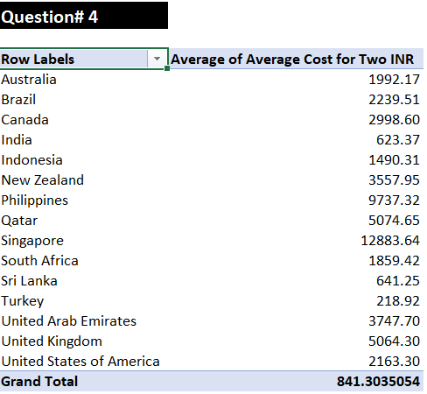

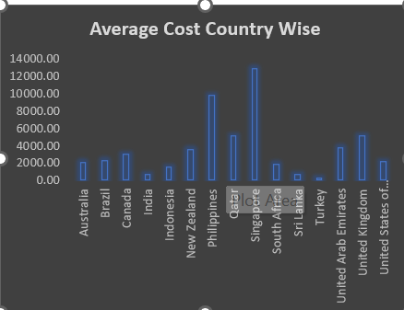

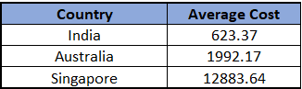

1. **Come up with the names of restaurants from the recommended states who are our biggest competitors and also those which are rated in the lower brackets, i.e. 1-2 or 2-3.**

How do you decide if anyone is a competitor?

As we have given the priority to the rating our biggest competitors are the restaurants with the rating 4-5.

There are a total 41 restaurants which are in 4-5 ratings in the suggested countries which are our biggest competitors.

Also, there are no restaurants with the lower bracket i.e.1-2 or 2-3 in the selected cities.

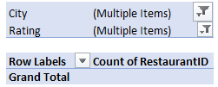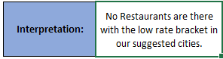

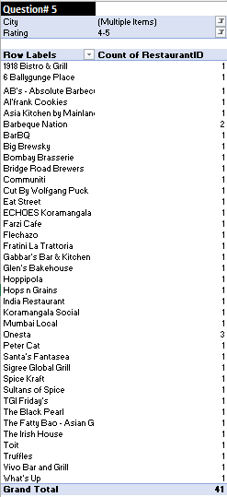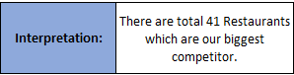

1. **Which cuisines should we focus on in the newer restaurants to get better feedback? Does the choice of cuisines affect the restaurant ratings?**

What is the basis for the suggestions? And mention how you decide if the cuisines affect the ratings?

* *As we have given the priority to the rating we will focus on the cuisines with the high rating as it would affect the average rating for our newer restaurant in a positive way. Yes, the choice of cuisines affect the restaurant ratings as the same cuisines but at different places have different ratings.*

1. **According to our current data, should we go for online delivery and table booking? Does that affect the customer’s ratings?**

Mention your approach and spreadsheet function for the answer.

* *As per the current data the rating is directly related to the online delivery and table booking. Average rating for the online booking and table booking is higher than the normal visit. Below are the observations that represent the same.*

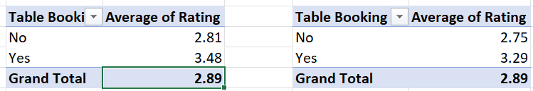

1. **Should the team keep the rate of cuisines higher? Will that affect the feedback? According to our data are the rate of cuisines and ratings, correlated?**

*Back the suggestion with proper insights and visualization.*

* *No. As there is no relation between the rate of cuisines and rating so we will maintain the rate as usual.*
* *Correlation between rate of cuisines and rating is almost near to no as the correlation coefficient value is 0.059 which is almost near to zero.*

**Below is the calculation for the same: =CORREL('Raw Data'!T2:T9552,'Raw Data'!U2:U9552)**

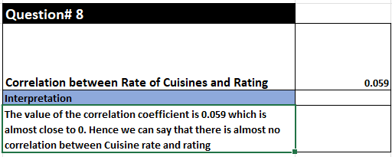

1. **What is the distribution of the number of restaurants of different price ranges in all the countries?**

Distribution means the numbers of different price ranges, how will you show this using a chart?

* *Distribution of the number of restaurants of different price range in all countries are as follows:*

